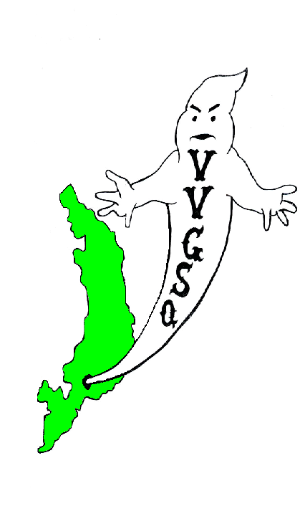
Vietnam Veterans Group of San Quentin

October 2012 General Meeting
Held in the Gym on October 28, 2012.

EXECUTIVE COMMITTEE:

Chairman | Chris Schuhmacher
Vice-Chairman | James Snider
Secretary/Treasurer | Dave Basile
Outside Coordinator | Greg Sanders
North Block Member-at-Large | Ernie Vick
H-Unit Member at Large | John Warren
West Block Member at Large | Craig Johnson

Chairman Schuhmacher called the group to order at 0915 hrs. All present were asked to remove their hats for a moment of silence for those Missing-in-Action, those Killed-in-Action, and all other service members deployed in Iraq, Afghanistan, and around the world.

ROLL CALL: 34 members present, 0 absent and 11-excused absences - there was a quorum. Our sponsor, Lt. K. Evans, was not present.

All members were asked if they received the September 2012 General Meeting minutes. All members did receive their minutes. A motion to accept the minutes requested by Mr. Barton, seconded by Mr. Rooke, and the motion passed.

SECRETARY/TREASURER'S REPORT:
We have in our account $2,292.24.

OUTSIDE COORDINATOR’S REPORT:
Mr. Sanders: The only correspondence received since our last meeting is a Thank You card from Operation Moms thanking the group. Mr. Sanders again introduced “Holiday Mail for Heroes”, that would require cards completed by veterans and mailed out. Mr. Sanders stated he had the cards and those interested in filling them out should see him after the meeting. Mr. Sanders stated that the cards had to be filled out and returned to him or Secretary Basile by 12/09/12.

COMMITTEE CHAIRMAN’S:

BY-LAWS:
Chairman Stan Baer: Committee member Daniels was introduced to Mr. Baer and they were to get to know each other after the meeting. No revisions yet proposed.

SCHOLARSHIP:
Chairman J. Robinson: Nothing to report at this time. Mr. Schuhmacher requested that information about the scholarship program be available at the VVGSQ information table on 11/11/12

HONOR GUARD:
Chairman Trent Capell: Honor Guard has been practicing and is ready for 11/11/12. Mr. Faison will play Taps at the designated time.

HISTORIAN/WEBSITE:
Chairman G. Sanders: JLynn unable to attend, but she should have some changes to our web page available the next time we meet.

STAMPS FOR SOLDIERS:
Chairman P. Rooke: Stamps were mailed out to our contact in Florida. However, we are waiting for confirmation of receipt. In addition, we have a local address for the Tabs. A letter was sent asking them if they want our tabs. The reason, cheaper to mail in California vs. Indiana.

FUND RAISER:
Chairman J. Hernandez: Meeting took place with Lt. Evans on 10/01/12 where it was decided to move forward with the mini canteen proposal. However, the proverbial wrench was thrown into the works when Mr. Bell announced that the proposed area for the canteen has been allocated to some other venture.

PRESENTATION AWARDS:
Chairman J. Gomez: Mr. Gomez said he would bring a prototype in for all to see and that he would like to have the wording and/or spooky logo made available so that he can see if the Weeke can do the inscription.

CAMARADERIE NIGHT:
Co-Chairman’s J. Warren stated nothing to report, as there is no sponsor available for this month. Mr. H. Barton stated the softball game scheduled for 10/21/12 was cancelled. However, it has been rescheduled for Sunday morning from 0900 to 1230 hrs on Nov 4, 2012. Be there or be square.
SQ MEDIA
Nothing to report at this time.

TOY PROGRAM
Co-Chairman’s G. Caffale and B. Spillman: Flyers for visiting room are and requests to ILTAGS and Chaplains for donations have been submitted. Lt. Evans is ordering toys this month and looking into a bigger truck to haul the toys to SQ.

FLAG FOLDING
Chairman D. Tarvan: Request two US flags 5’ x 9’, tabled until November meeting.

VIP OFFICE:
The next scheduled workshop is November 16, 2012.

OLD BUSINESS:

Mr. Robinson stated to the group that he has (1) bat, plenty of gloves and teams lined up to play softball with us old veterans. Mr. Tarvan stated that the Kid Cat hygiene drive requests that (1) we set up a bin in the housing block where we can donate hygiene products and (2) to use our name and time to solicit vendors and/or business to donate as well. Lengthy discussion took place with the following result. Let Kid Cat know that we are not going to use our name to solicit outside vendors. Bring a proposal to the next meeting so the group can vote on it. Mr. Vick brought up the idea of having some kind of sticker for our door to indicate we are veterans. Mr. Schuhmacher said to bring it up next month.

NEW BUSINESS:
Mr. Schuhmacher requested that on Veterans’ day we have an information table placed on the yard. In addition, all members wanting to participate to sign the form provided. Mr. Schuhmacher announced that Kid Cat is holding their card-signing program for the children of Oakland Children’s Hospital in November. All interested were asked to sign up on the form provided. Veteran Daniels asked to say a few words before going behind the soundproof curtain prior to the membership’s vote. Once he left, the membership convened to vote him in as a member. The vote passed in favor of acceptance. Congratulations Mr. Daniels and welcome aboard. That concluded New Business.

A motion to adjourn the meeting by Mr. Beavers and seconded by Mr. Barton. A vote was taken and the motion passed. The meeting adjourned at 1025 hrs.

UPCOMING EVENTS

November 4, 2012 | Camaraderie Baseball Game on the Yard @ 0900 hrs
November 11, 2012 | Veterans Roll Call on lower yard @ 0900 hrs
November 18, 2012 | Kid Cat Christmas Card Signing ARC Trailer (Time TBD)
December 2, 2012 | General Meeting in the Library @ 0900 hrs
Dec 15, 16, 2012 | Holiday Toy Program in Visiting Room
Dec 22, 23, 2012 | Holiday Toy Program in Visiting Room

Submitted,

__________________________ __________________
D. Basile, DATE
V.V.G.S.Q. Secretary / Treasurer

__________________________ __________________
C. Schuhmacher DATE
V.V.G.S.Q. Chairman

NOTED

__________________________ __________________
R. Luna DATE
Correctional Lieutenant
V.V.G.S.Q. Co-Sponsor

Vietnam Veterans Group of San Quentin  Attn: Lt. K. Evans, Chief sponsor  San Quentin State Prison  1 Main Street  San Quentin, CA 94964-0001  Website: http://vvgsq.tripod.com/ | Chief Sponsor: Lt. K. Evans, (415) 454-1460 x 5205  Co-Sponsor: Lt. R. Luna, (415) 454-1460 x 5808

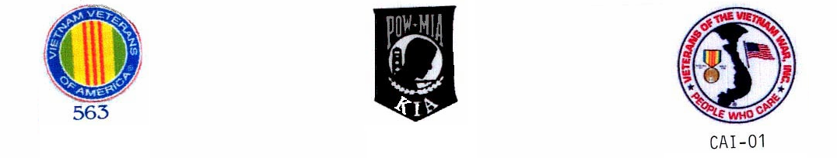
CURRENT ROSTER as of 10/30/12

 | NAME | CDC # | HOUSE | ETH. | CUST. | STATUS | COMMENTS
√ | ADAMS DWIGHT | K-98701 | 1N073L | BLK | CLOB | Voting Mbr | Fundraiser
√ | ARNOLD, RICHARD | P-27171 | 2N069U | WHI | CLOB | Voting Mbr | Website/Historian
√ | BAER, STAN | K-06285 | 3N039U | WHI | MEDA | Voting Mbr | VIG, Toy Prog/By-laws Chr
√ | BARTON, HARRY | C-03120 | 2W068L | WHI | MEDA | Voting Mbr | VIG, Camaraderie
√ | BASILE, DAVID | C-70016 | 1N038U | WHI | MEDA | Voting Mbr | Secretary/Treasurer
√ | BEAVERS, LAWSON | P-14974 | 1N015L | BLA | CLOB | Voting Mbr | VIG, Honor Guard, Toy Prog, Camd.
√ | BELL, CHRISTOPHER | K-01545 | 2D026L | BLA | CLOB | Probationary | Probationary until Nov 25, 2012
E | BOTHA, GARY | D-88086 | 1W095L | WHI | MEDA | Voting Mbr | Scholarship
E | BUTLER, DUANE S. | D-91464 | 2N017L | BLA | MEDA | Voting Mbr | VIG, Fundraiser
√ | CAFFALE, GEO | D-97941 | 3N098L | WHI | MEDA | Voting Mbr | VIG, Toy program co-Chr.
√ | CAPELL, TRENTON | E-91949 | 3N011U | BLA | CLOB | Voting Mbr | Chairman Honor Guard
√ | COLEMAN, RONALD | C-87435 | 2W010L | BLA | MEDA | Voting Mbr
√ | COOPER, GARY | T-15604 | 3W013L | WHI | CLOB | Voting Mbr | Toy Program
√ | DANIELS, ISIAL | K-37959 | 2W022l | BLA | MEDA | Voting Mbr | By-Laws, Scholarship
√ | ESPINAL, PEDRO | K-94652 | 1N087U | OTH | CLOB | Voting Mbr
√ | FAISON, POPEYE | C-68462 | 2N028U | BLA | MEDA | Voting Mbr | VIG,Toy Program
√ | FARRIS, DARRYL | T-33812 | 5N071U | BLK | CLOB | Voting Mbr | Scholarship
√ | GASKINS, SAMUEL | C-27569 | 3W079L | BLK | MEDA | Voting Mbr | Honor Guard, Flag Folding
√ | GOMEZ, JOHNNY | K-72622 | 4N042L | MEX | CLOB | Voting Mbr | VIG, Awards Ch. Toy Prog.
√ | GOODLOW, KENNETH | C-75705 | 1D043L | BLA | CLOB | Voting Mbr | Camaraderie
√ | GUMPAL, MAURO | P-00591 | 4N036L | OTH | CLOB | Voting Mbr | Honor Guard
√ | HARRIS, MARVIN | C-91589 | 2W093L | BLK | MEDA | Voting Mbr | Toy Program
√ | HERNANDEZ, JESSE | K-21116 | 2W036L | WHI | MEDA | Voting Mbr | Fund raiser Chairman Website
√ | HYLTON, ROBERT | AI4554 | 4H077L | WHI | MEDA | Voting Mbr | Toy Program, Camaraderie
 | JENKINS, DONALD | C-37245 | 4N030L | BLK | MEDA | PROBATION | Probationary until January 2013
√ | JOHNSON, CRAIG | C-08327 | 4W063L | WHI | MEDA | Voting Mbr | VIG,Honor Guard, WB Mbr @ Large
E | JOHNSTON, JOHN | F-01795 | 4H045L | WHI | MEDA | Voting Mbr | Camaraderie
E | JONES, MALCOLM | J-04780 | 5W010L | BLA | CLOB | Voting Mbr | VIG
E | KASER, BOB | D-41415 | 2N025L | WHI | MEDA | Voting Mbr | VIG
E | KESS, PHILLIP | G-62396 | 5H057L | BLA | MEDB | Voting Mbr
E | MARTIN, J.D. | D-44170 | 4W075L | BLA | MEDA | Voting Mbr | Flag Folding, Camaraderie
√ | POLLEY, AHMAD | C-57727 | 2W084L | BLA | MEDA | Voting Mbr | VIG, Honor Guard
√ | ROBINSON, GARVIN | K-52086 | 3N012L | BLA | CLOB | Voting Mbr | Honor Guard, Sch Chr.Flg Fldg
√ | ROOKE, PETE | C-76159 | 1N020L | WHI | CLOB | Voting Mbr | Tabs/Stamps for Soldiers
√ | SANDERS, GREG | E-05222 | 4W017L | WHI | MEDA | Voting Mbr | VIG Out Coor. Chr Website His
√ | SCHUHMACHER, CHRIS | T-31014 | 4N093L | WHI | MEDA | Voting Mbr | Chairman
√ | SNIDER, JAMES | F-30077 | 2N100U | WHI | CLOB | Voting Mbr | VIG, Vice- Chr. Media
√ | SOLTERO, DANIEL | D-65858 | 1W006U | WHI | CLOB | Voting Mbr | Honor Guard, DB Mbr @ Large
√ | SPILLMAN, GLEN | F-42695 | 3N035U | WHI | CLOB | Voting Mbr | VIG, Co-Chr. Toy Prog. Awards
E | STAUFFER, PAUL | T-80750 | 3N065U | WHI | CLOB | Voting Mbr | Scholarship, Media
E | STEWART, NORFLEET | E-90026 | 4W079L | BLA | CLOB | Voting Mbr | Honor Guard, Flag Folding
E | STONER, JEFFREY | D03596 | 5W085U | WHI | MEDA | Voting Mbr | Website/Historian
√ | TARVAN, DAVID | E-76518 | 2W038L | WHI | MEDA | Voting Mbr | Honor Guard
√ | VICK, ERNIE | P-59262 | 2N016L | WHI | CLOB | Voting Mbr | VIG Scholar,Fund NB Mbr @ Lg
√ | WARREN, JOHN | T-86358 | 4H065L | MEX | MEDB | Voting Mbr | Cam Co-Chr H Mbr @ Large
√ | WOODS. JIMMIE | V-68113 | 5H035L | BLA | MEDB | Voting Mbr | Camaraderie
46

√ = Present
E = Excused Absence
A = Unexcused Absence

